**Movie Landing Page Website Design**

|  |  |
| --- | --- |
| **Name** | **:** Ravulapalli Nagaraju |
| **Email** | **:**  R.NAGARAJU8179@gmail.com |
| **Roll NO** | **: 20HU1A0440** |

**College Name : Chebrolu engineering college**

**Phone number:**8179724536

**source code:**

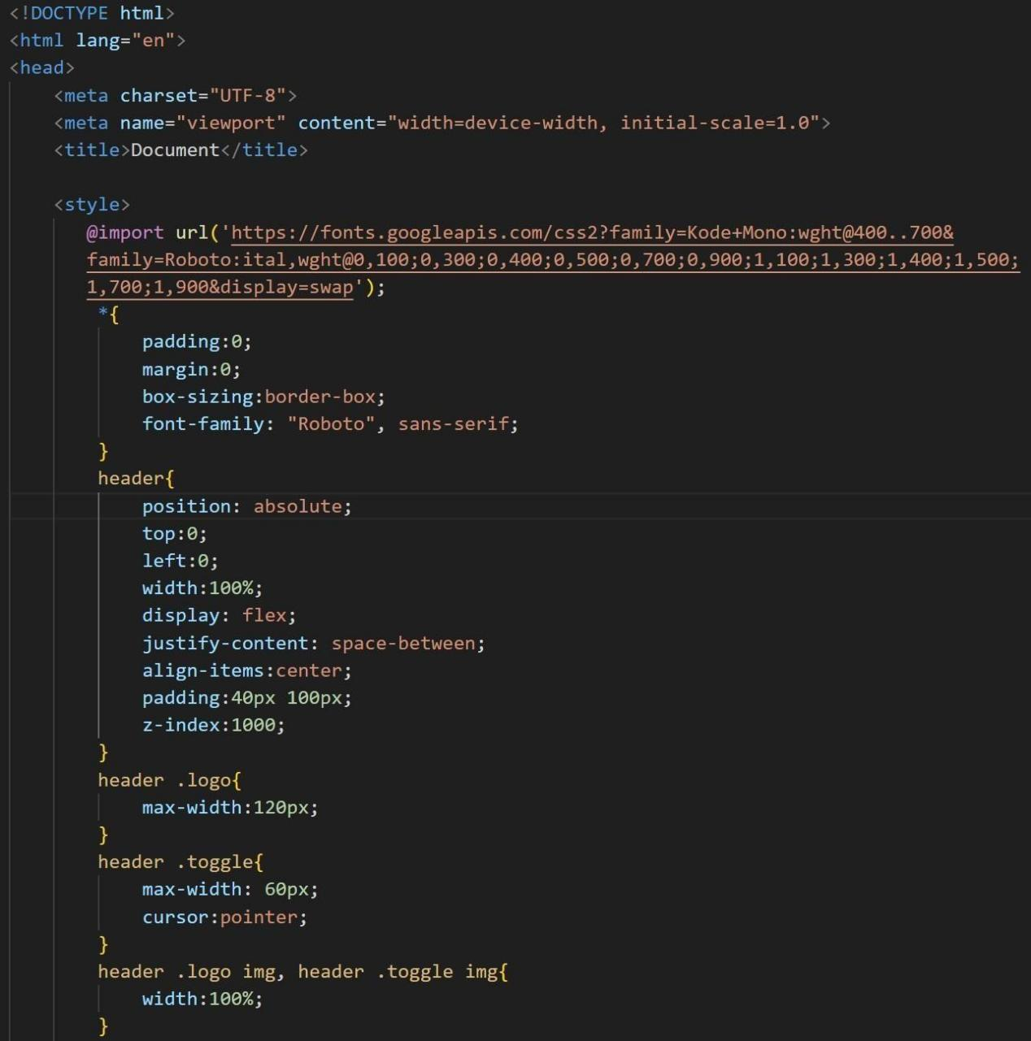

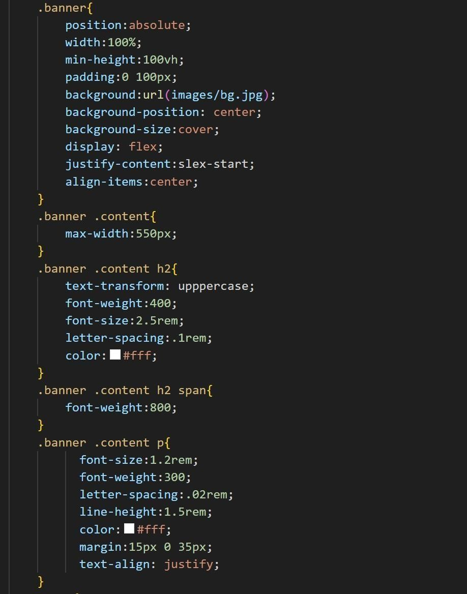

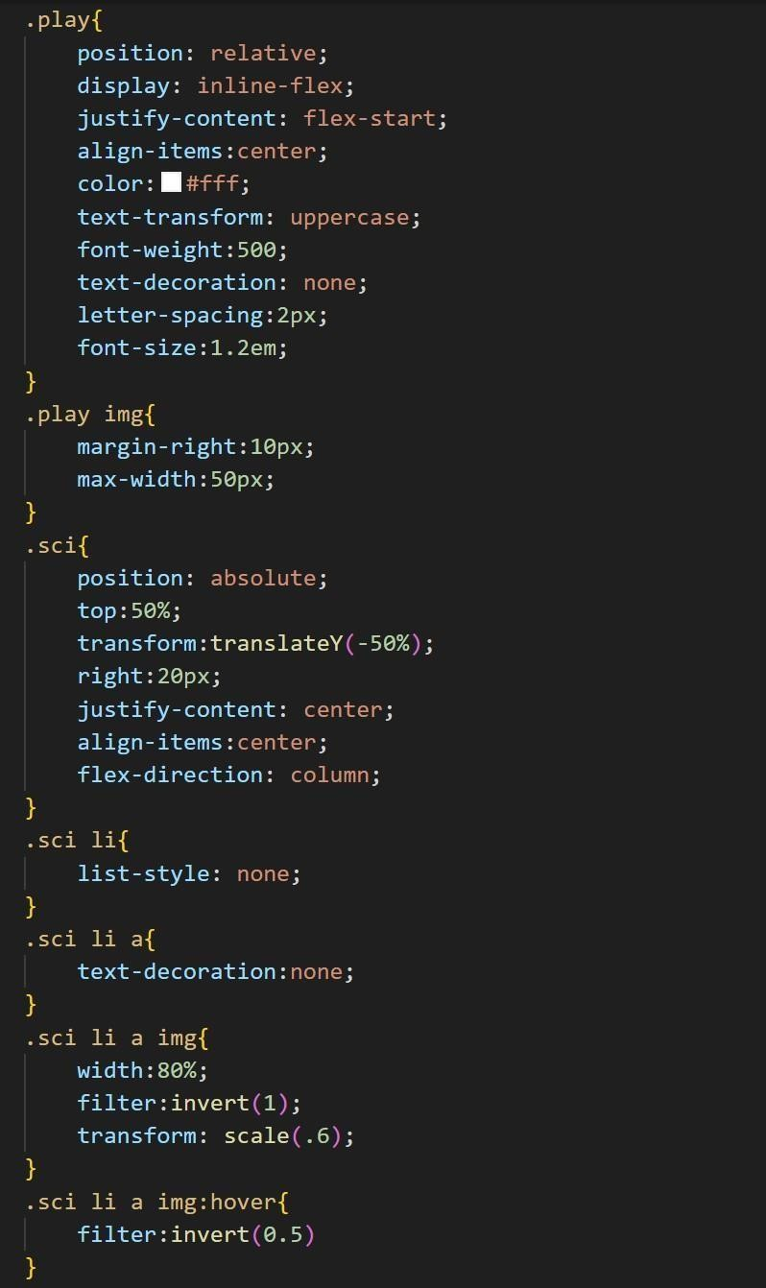

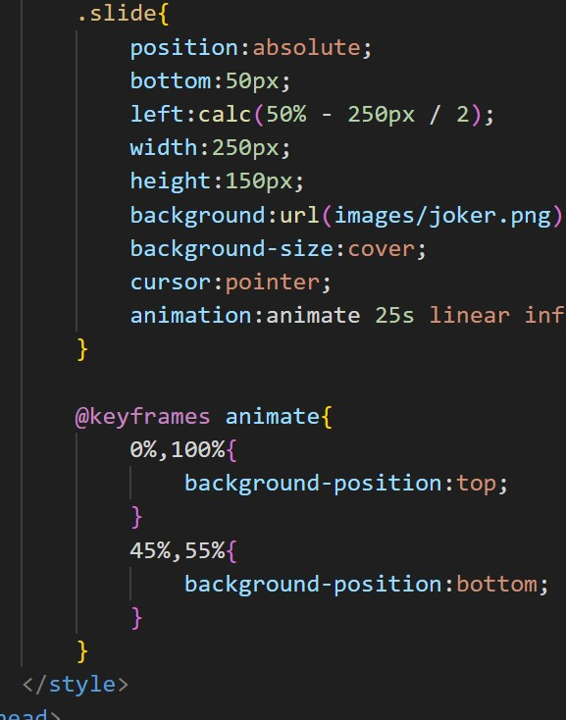

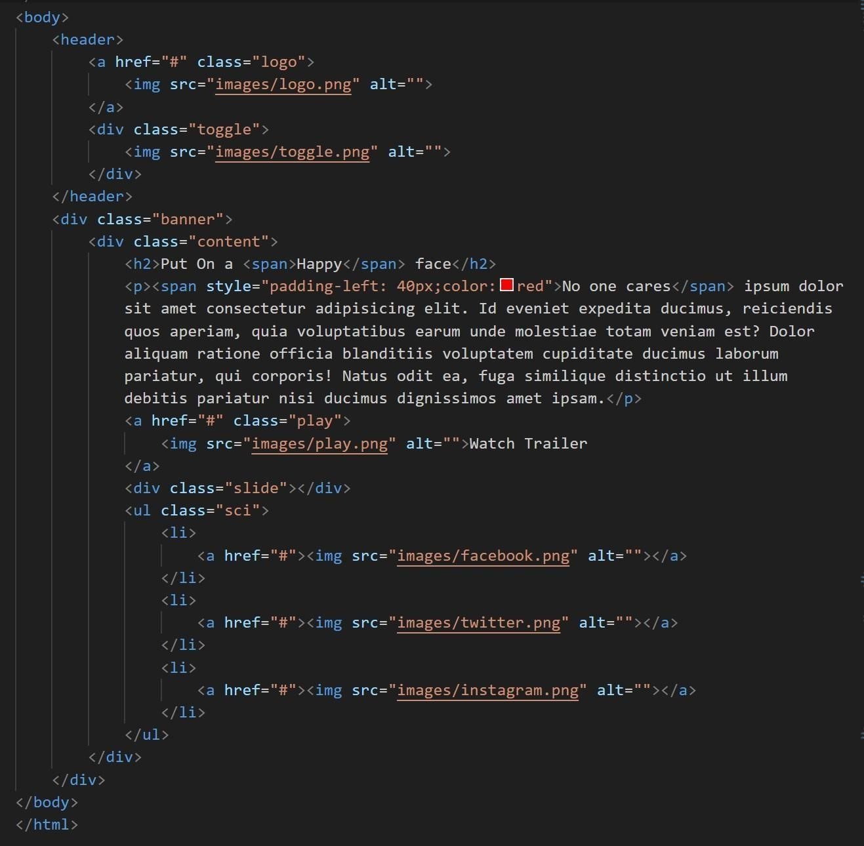

**flnal output :**

